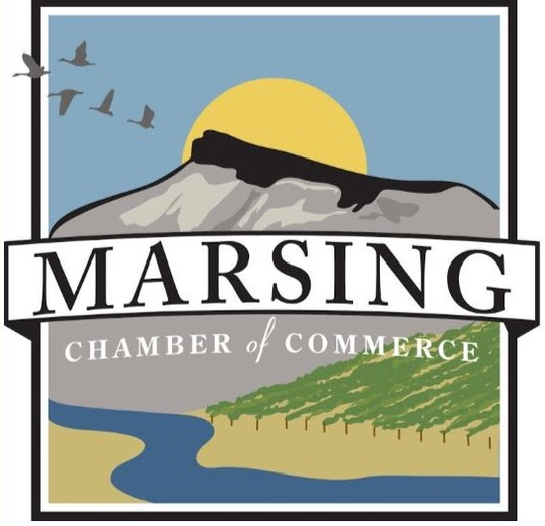

2022 2023

MEMBERSHIP APPLICATION - MARSING CHAMBER OF COMMERCE
Marsing Chamber of Commerce Steve Derricott, Chamber President
P.O. Box 247 marsingchamber@gmail.com
Marsing, ID 83639 www.facebook.com/MarsingChamber
208-896-4935 www.marsingchamber.org
Welcome to the Chamber! We are excited to have you as a MEMBER!
Your support is greatly appreciated!
The Chamber’s focus for 2022-23:
The Chamber hosts the Marsing Christmas Parade on Main Street
and the annual Marsing Trunk or Treat, Halloween Event

We have monthly meetings that provide opportunities to NETWORK and get involved in the community.
MEMBERS may attend business training seminars hosted by the Marsing Chamber of Commerce
MEMBERS will receive a Membership Certificate to post in their business
MEMBERS will be featured on our Marsing Chamber Facebook and website
MEMBERS have the option to have a Ribbon Cutting
MEMBERS have the opportunity to Promote their Business while Networking with other businesses
MEMBERS participate in a healthy, vibrant business environment to improve the local community

Please mail $50.00 check payable to Marsing Chamber to PO Box 247, Marsing, ID 83639
Business Name ___________________________________________________________________________________________
Physical Address:_________________________________________________________________________________________
Mailing Address: _________________________________________________________________________________________
Contact Name_______________________________________ Contact Phone # (____)____________________________
Email ________________________________________Website URL_________________________________________________
Donation: ____________________________________ THANK YOU FOR SUPPORTING OUR COMMUNITY !

